# PRECIOUS OREWEME CONTRIBUTIONS

**NAME: OREWEME PRECIOUS**

**TEAM: 53**

**STUDENT ID: 14G001549Q4X**

**PRODUCT : MiQr ( A QR code generator)**

## 

## DOCUMENTATION(project brief)

[Team 53_QRgen(2)](https://docs.google.com/document/d/1jPa1mgFY8IklWsggStzxsIuvVkPeSq8vuMkou0qwvvs/edit?usp=sharing)

## PROTOTYPING(ANIMATION): Desktop View

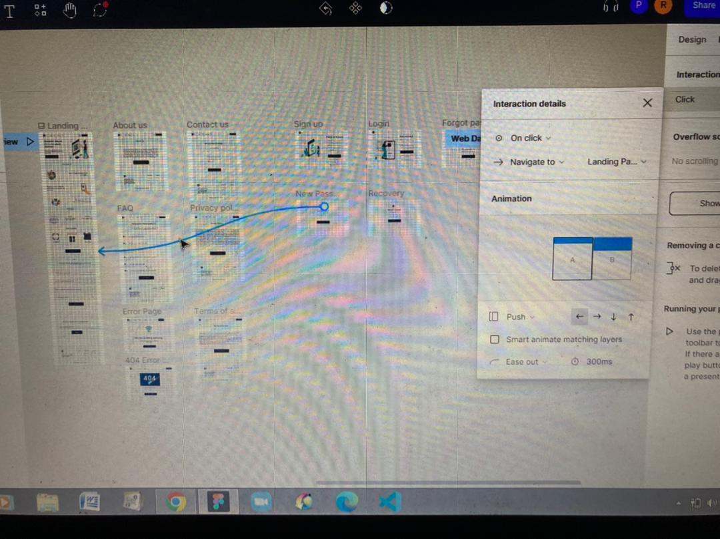

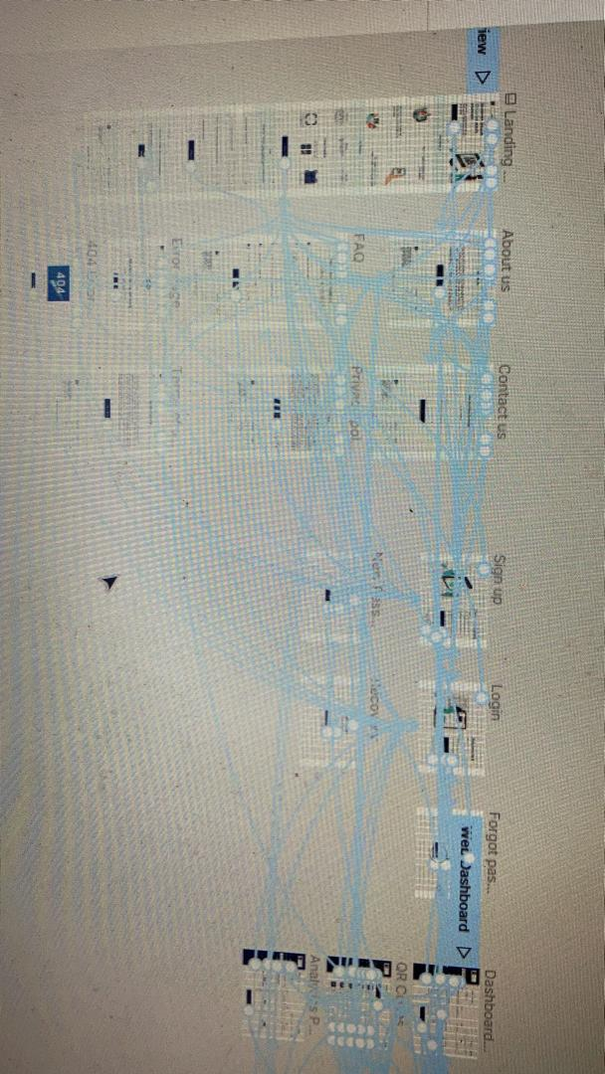

## 

## 

## 

## 

## 

## 

## UX writing(Idea prioritisation map):

